Ads for

Dummies

This document serves as a comprehensive guide for navigating various Facebook advertising scenarios. It is designed to assist team members of Waiz Media in understanding the steps required for different client situations related to Facebook advertising.

Facebook Setup for Beginners
This guide walks through key Facebook setups. It’s broken into different situations, so skip to the section that applies.

Easy as 1, 2, 3!
These steps are completed on the client’s end—no approval needed from our side!
- Give the client our Business ID: BUSINESSID
- They add us as a PARTNER.
- They share assets (Facebook Page & Ad Account).

How to Do It (Client Instructions)
- Log in to business.facebook.com.
- Navigate to Partners on the left-hand menu.
- Click the ADD button.
- Choose: "Give a partner access to your assets."
- Grant access to both:
  - Facebook Page
  - Ad Account (if applicable)
- Enter our Business ID: BUSINESSID.
- Review permissions (ensure proper access levels).
- Submit to complete the process.
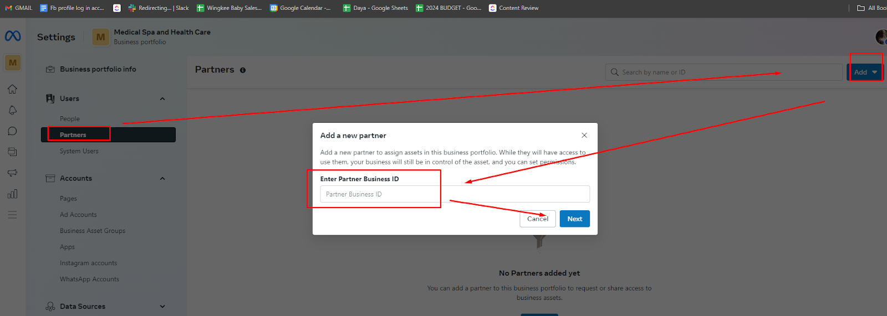

Note:
- If the client doesn’t have a Business Manager or isn’t an Ad Account Admin, you’ll need to handle setup on our side.
- In this case: The remaining setup tasks will be DONE ON OUR END.

1. If They HAVE an Ad Account
- Log in to Facebook Business Manager: business.facebook.com
- Go to Business Settings > Accounts > Ad Accounts.
- Confirm that your Ad Account is listed.
- If it’s missing, request access by:
  - Click “Add” > “Request Access to an Ad Account.”
  - Enter the Ad Account ID (can be found by the client if they provide it).
- Verify Permissions:
  - Ensure you have Admin or Advertiser access (View-only isn’t enough for most tasks).

2. If They DON’T Have an Ad Account
- Create One
  - Go to Business Settings > Accounts > Ad Accounts.
  - Click “Add” > Create a New Ad Account.
  - Follow the prompts (Give it a name, set the currency, and choose the Business).
- Assign Permissions:
  - Give your team members appropriate roles (Admin, Advertiser, Analyst, etc.).
- Connect Payment:
  - Under Payments, set up a valid payment method (Credit Card, PayPal, or Direct Debit).

3. If They HAVE a Facebook Page
- Check Page Access in Business Manager:
  - Go to Business Settings > Accounts > Pages.
  - If their page is there, confirm you have the right role (Admin/Editor).
  - If it’s missing, request access:
    - Click “Add” > “Request Access to a Page.”
    - Search for the Page or enter its name.

- Verify Ownership:
  - If access is pending, the client needs to approve your request.

4. If They DON’T Have a Facebook Page
- Create the Page:
  - Go to business.facebook.com/pages/creation.
  - Choose a category (e.g., Local Business, Community, Brand, etc.).
  - Add the necessary details (Page name, profile picture, about section).
- Assign Roles:
  - Go to Page Settings > Page Roles and add admins or editors.
  - Ensure relevant people have appropriate access to manage the page and ads.

Facebook Setup - Understanding Assets
This guide explains both the main setup scenarios and the finer points of Business Portfolio Access for seamless asset sharing.

How to Find the Business ID
- Navigate to business.facebook.com and log in.
- Business ID Location:
  - It’s visible in the URL when you are inside the Business Manager.
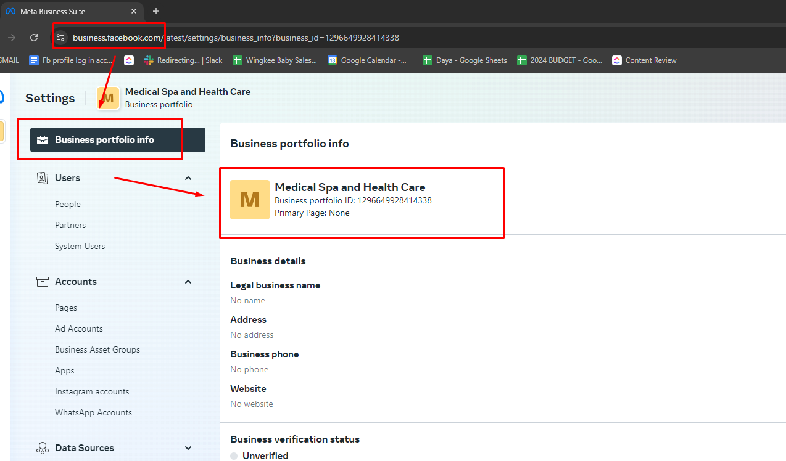
    - Example: https://business.facebook.com/settings/business/1234567890
    - Business ID in this case: 1234567890
  - Alternatively, navigate to Business Settings, and the ID will be displayed under Business Info.
Pro Tip: If you're ever unsure, always check the URL for the Business ID—it’s the fastest way!
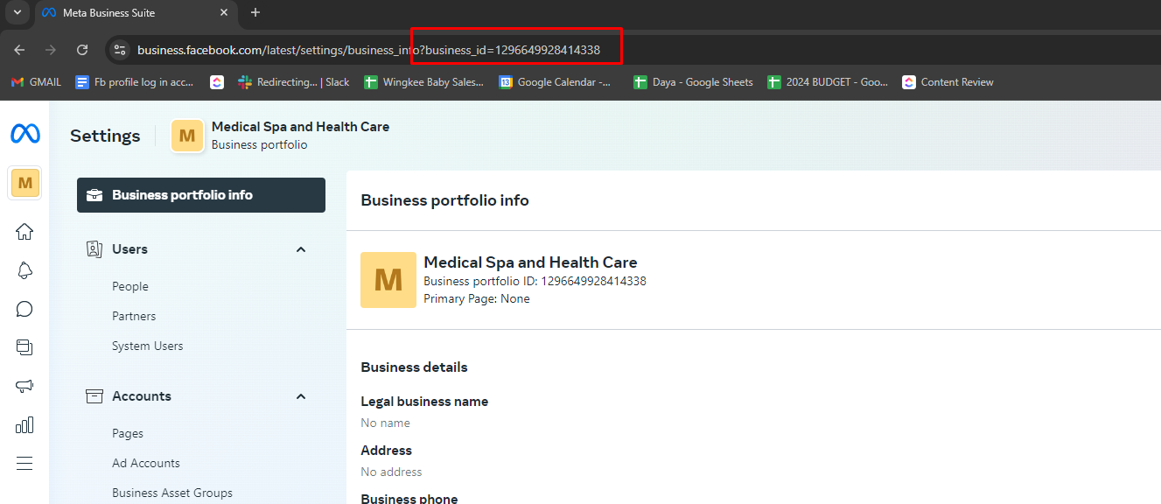

Requesting Business Portfolio Access from Partners
Use this when you need full control over assets like ad accounts or Facebook pages.

Steps to Request Access:
- Log in to Facebook Business Manager.
- Go to Business Settings from the main menu on the left.
- Select Partners from the left sidebar.
- Click Add.
- Choose: “Request Access to a Business Portfolio.”
- Enter the Client’s Business Portfolio ID (provided by the client).
- Set the Access Level: Select Full Control.
- Submit the Request: Click Submit to send your request for the client’s approval.
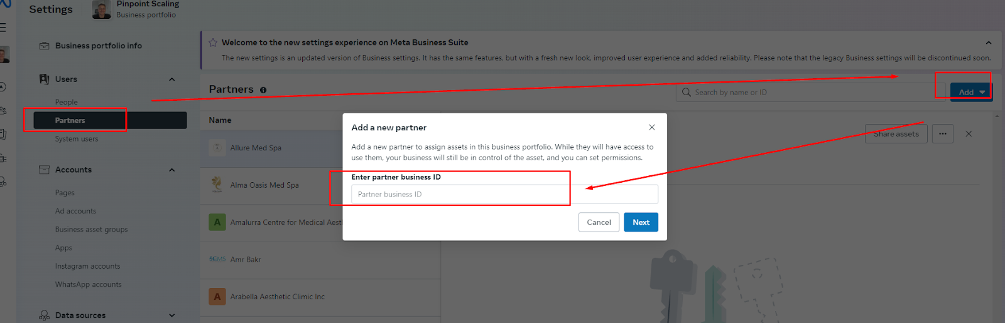

How Clients Can Approve Business Portfolio Access
Follow these steps to help the client approve your request for Business Portfolio access.

Steps for the Client to Approve:
- Log in to Facebook Business Manager.
- Go to Business Settings from the left-hand sidebar.
- Select Partners from the menu.
- Look for Pending Requests under the Access Requests section.
- Find the Request: Locate your specific request for Business Portfolio access.
- Review the Request Details, including the level of access requested.
- Click Approve to grant access.
- Receive Confirmation: After approval, you’ll get a notification confirming that access has been granted.
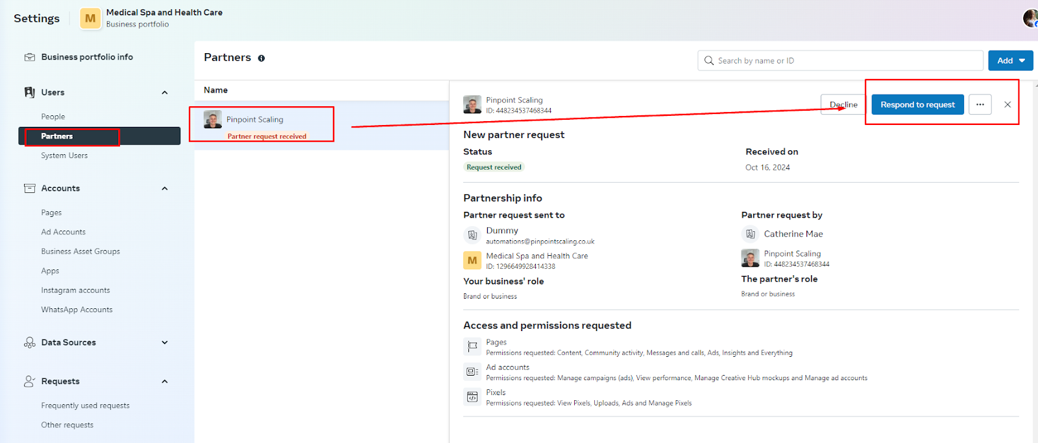

Why This Matters: Understanding Assets and Roles
- Ad Accounts: Control who can create and manage campaigns.
- Facebook Pages: Assign admins and editors for content management.
- Business Portfolio: A collection of all assets (Pages, Ad Accounts, Pixels, Catalogs) under a Business Manager.
- Partner Access: Enables one Business Manager to access another's assets with set permissions.

Providing and Requesting Ad Account Access

Scenario 1: How Clients Provide Ad Account Access
- Log in to Facebook Business Manager.
- Go to Ad Accounts:
  - Navigate to Business Settings > Accounts > Ad Accounts.
- Select the Ad Account you want to share access to.
- Assign Partner Access:
  - Click Add People or Add Partners (depending on your interface).
  - Choose Assign a Partner.
- Enter our Business ID:
  - Use this ID: BUSINESSID.
- Set the Permissions:
  - Check “Full Control” to ensure we can manage all aspects of the ad account.
- Click Assign to complete the process.

If the Client Can’t Add Partners
- If the client isn’t able to add partners or share access, we’ll create the Ad Account under their Business Portfolio.

Scenario 2: No Ad Account Exists

How to Create a New Ad Account under Their Business Portfolio - Reach out to our Marketing Manager or get the client to create one under their facebook user.
- Log in to Facebook Business Manager.
- Go to Business Settings > Accounts > Ad Accounts.
- Click “Add” > Create New Ad Account.
- Fill out the necessary fields:
  - Name of the Ad Account.
  - Currency and Time Zone (ensure they match the business region).
  - Select the Business Portfolio as the owner of the account.
- Click “Create Ad Account.”
- Once created, assign us as a partner using the Business ID: BUSINESSID.

Scenario 3: How to Request Ad Account Access on Our End
- Log in to Facebook Business Manager. Go to Business Settings > Ad Accounts.
- Click “Add” > Request Access to an Ad Account.
- Enter the Ad Account ID (provided by the client).
  - Pro Tip: Clients can find the Ad Account ID in the URL when viewing their ad account.
- Select the required level of access:
  - Options include View Performance, Manage Campaigns, or Full Control.
- Submit the request and wait for the client to approve.

How Clients Can Approve Ad Account Access
- Log in to Facebook Business Manager.
- Go to Business Settings from the left-hand sidebar.
- Select Users > People (or Partners if applicable).
- Look for Pending Requests under the Ad Accounts section.
- Find and Review the Request:
  - Click the request to view the details and requested access level.
- Approve or Deny the Request:
  - If everything looks good, click Approve to grant access.
  - If needed, adjust the level of access before approving.
- Confirmation:
  - Once approved, a notification will confirm that access has been granted.

Creating and Sharing Facebook Page Access
This document outlines how to create a Facebook Page, share access using Business Manager or directly from the Page, and handle different scenarios, including giving admin access to our media buyer.

1. How to Create a New Facebook Page
If the client does not have a Facebook Page, follow these steps:

Creating a Page from the Client’s Facebook Account
- Log in to Business Manager: through the link pinned at the top of the client management on monday.com
- Access the Menu:
  - Click the menu icon (three horizontal lines) in the top right corner.
- Go to Pages:
  - From the menu, select Pages.
- Create a New Page:
  - Click on Create New Page.
- Enter the Page Details:
  - Page Name: Enter the business or organization name.
  - Category: Select a category (e.g., business, community, non-profit).
  - Description: Provide a brief summary about the business.
- Add a Profile and Cover Photo:
  - Upload relevant images for the Page Profile and Cover Photo.
- Click Save to finalize the setup.
- Page Setup Complete: The Facebook Page is now ready to use!

2. Sharing Access to the Facebook Page
There are two ways to share access: via Business Manager or directly from the Facebook Page settings. Here’s how:

Scenario 1: Sharing Access Through Business Manager
- Log in to Business Manager: through the link pinned at the top of the client management on monday.com
- Go to Business Settings:
  - Navigate to Accounts > Pages.
- Select the Page: Choose the Facebook Page to share.
- Add a Partner:
  - Click Add Partner > Assign Partner Using Business ID.
- Enter our Business ID: Use BUSINESSID.
- Set Permissions:
  - Check Full Control to grant full management access.
- Click Assign to complete the process.
- Notify the Client: They will need to accept the invitation from their Business Manager.
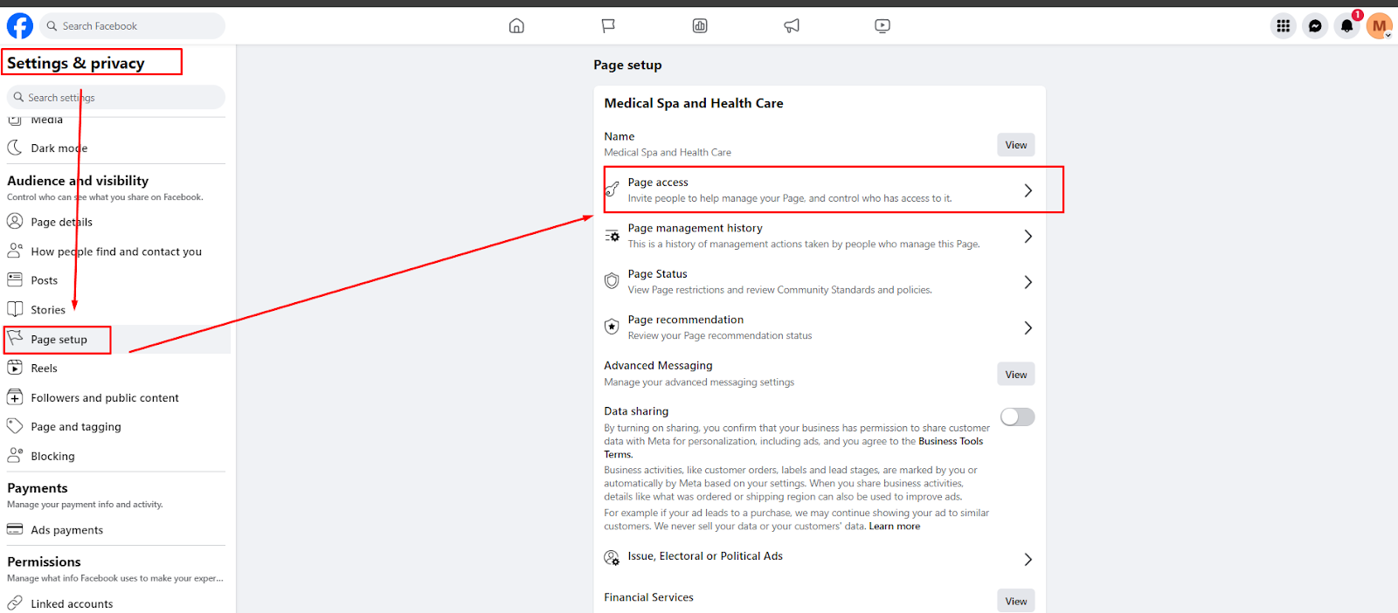

Scenario 2: Sharing Access Directly from the Facebook Page
If the client’s Page is not connected to Business Manager or they lack admin rights in their Business Portfolio, use this method:
- Access the Facebook Page:
  - Log in to Facebook and go to the specific Page.
- Go to Page Settings:
  - Click Settings from the left sidebar.
- Select Page Roles:
  - In the left-hand menu, click Page Setup (for the new Page experience) or Page Roles (for classic Pages).
- Add a New Role:
  - In the Assign a New Page Role section, enter the email address or Facebook username of the person you want to add.
  - Example: Add Mae Pajanostan, our Media Buyer, as Admin.
- Select Role:
  - Choose Admin to give full control of the Page.
- Click Add to send the invitation.
- Notify the Media Buyer: Mae will need to accept the invitation from her notifications or email.
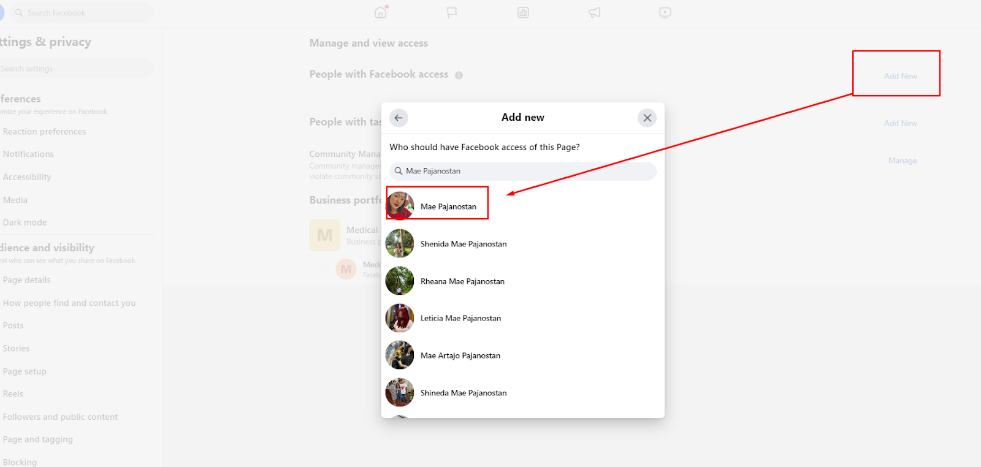

3. Giving the Client Admin Access to a Page Created by Us
If we created the Facebook Page under our Business Portfolio, follow these steps to transfer or share access with the client.

Option 1: Adding the Client as a Partner through Business Manager
- Log in to Business Manager.
- Go to Business Settings > Accounts > Pages.
- Select the Page we created.
- Click Add Partner:
  - Enter the client’s Business Manager ID (ask the client to provide it).
- Set Permissions:
  - Assign Full Control to the client to ensure they have full management access.
- Click Assign.
- Notify the Client to accept the invitation in their Business Manager under Pending Requests.

Option 2: Adding the Client Directly from the Page Settings
- Open the Page: Log in to Facebook and access the Page.
- Go to Page Settings: Click Settings from the left menu.
- Select Page Roles:
  - Go to Page Setup (for the new experience) or Page Roles.
- Add the Client’s Email or Username:
  - Enter the client’s Facebook account details.
- Assign Role:
  - Choose Admin to give full access.
- Click Send Invite.
- Notify the Client to accept the invitation through their Facebook notifications or email.

4. Requesting Access to the Page on Our End
If the client prefers, they can share their Page ID, and we’ll request access ourselves.
- Log in to Business Manager.
- Go to Business Settings > Accounts > Pages.
- Click Add > Request Access to a Page.
- Enter the Page ID (provided by the client).
- Select the required permissions:
  - Options include Admin, Editor, or Advertiser.
- Submit the request and notify the client to approve it.

5. How Clients Approve Page Access Requests
If we’ve requested access, the client can approve it by following these steps:
- Log in to Business Manager.
- Go to Business Settings > Users > Partners or People.
- Find Pending Requests under Pages.
- Locate the Request: Click the specific request for details.
- Approve the Request:
  - Click Approve to grant access.
  - If needed, adjust the level of access before approving.
- Confirmation: Once approved, the client will receive a notification.

Handling Facebook Account Restrictions and Payment Issues
This SOP outlines how to manage Facebook account restrictions, such as payment method issues, content violations, or other compliance problems. It also details how to handle verification code requests and ensure that the Media Buyer coordinates with the Client Success Manager (CSM) to work directly with clients for resolution.

Types of Facebook Restrictions and Resolution Steps

1. Payment Method Issues
When Facebook restricts an ad account due to payment failures, this usually means the payment method on file has expired, been declined, or there are outstanding payments.

Steps for Media Buyer and Client Success Team
- Media Buyer Actions:
  - Pause active campaigns to prevent further issues until resolved.
  - Notify the CSM immediately about the restriction through monday.com and submit a ticket to them.

- CSM to Client:
  - Reach out to the client to explain the issue.
  - Schedule a call with the client to walk them through payment updates if needed.
- Client Action (On Call):
  - Log in to Business Manager through the link pinned at the top of the client management on monday.com
  - Navigate to Payment Settings:
    - Go to Business Settings > Payments.
  - Update the Payment Method:
    - Add a new card or ensure the existing one is valid.
  - Clear Any Outstanding Balance:
    - Make sure all outstanding invoices are paid.
  - Verify Billing Information:
    - Confirm that the billing address matches the card on file.

- Next Steps:
  - Media Buyer monitors to see if the restriction lifts.
  - If issues persist, escalate to Facebook Support through the Help Center.

2. Content Violations
Facebook may restrict accounts if an ad, post, or page violates community standards or ad policies.

Steps for Media Buyer and CSM Coordination
- Media Buyer Actions:
  - Log in to Business Manager through the link pinned at the top of the client management on monday.com
  - Review Policy Violations:
    - Navigate to Account Quality > Policy Violations.
  - Submit an Appeal (if applicable):
    - Click on the specific violation and select Request Review if the content complies with policies.
  - Remove or Edit Violating Content:
    - Delete or update the offending content to comply with Facebook’s standards.
- Next Steps:
  - Media Buyer will monitor the account status and provide updates to the CSM and the client.
  - If necessary, escalate to Facebook Support through the Help Center
  - Worst case scenario: Transition ads to a new ad account ( this a entire different topic and it’s out of ad for dummies guide )

3. Restricted Due to Account Security or Verification Requirements
Sometimes Facebook restricts accounts for security concerns, such as missing verification or suspicious activity.

Steps for Media Buyer and CSM Coordination
- Media Buyer Actions:
  - Identify the reason for the restriction: Check notifications and Account Quality in Business Manager.
  - Notify the CSM about the restriction and submit a ticket.
- CSM to Client:
  - Schedule a call with the client to complete any required verification steps.
- Client Action (On Call):
  - Log in to Business Manager through the link pinned at the top of the client management on monday.com
  - Navigate to Security Center:
    - Go to Business Settings > Security Center if prompted for security checks.
  - Upload Necessary Documents:
    - If Facebook requests ID verification or business documents, the client will need to upload them through the portal.
  - Handle Verification Codes:
    - If Facebook sends a verification code to the client’s phone, the CSM or Media Buyer must:
      - Call the client directly to retrieve the code.
      - Enter the code promptly in Facebook’s verification field.
    - Note: Verification codes are time-sensitive, so ensure the client is available on the call.
- Next Steps:
  - Monitor the account for status updates.
  - Escalate to Facebook Support if verification issues persist.

Meta Advertising Policies for the Beauty and Healthcare Industries
Meta’s advertising policies aim to create a safe and positive experience for users. Advertisers in the beauty and healthcare industries must adhere to these specific guidelines to prevent ad disapproval and account restrictions.

1. Prohibited Content

Health-Related Claims
- No Unsubstantiated Health Claims: Advertisements must not make misleading or exaggerated claims about health benefits. For example, avoid stating that a product can cure, prevent, or treat a disease without robust scientific evidence.
- Prohibition of Specific Drugs and Treatments: Certain medications, including prescription drugs like semaglutide, cannot be mentioned directly in advertisements unless the advertiser is authorized to do so.

Before and After Images
- Prohibition of Before-and-After Photos: Ads that showcase before-and-after images to demonstrate the effectiveness of beauty or healthcare products (e.g., cosmetic treatments, weight loss) are generally not permitted. These images can be misleading and set unrealistic expectations.

Personal Health Information
- No Personal Testimonials: Avoid using personal testimonials that claim specific results, especially if they can be interpreted as guarantees of performance. Ads should not use phrases like “I lost X pounds” or “This product changed my life.”

Sensitive Topics
- Prohibition on Sensitive Topics: Advertisements should not discuss sensitive health issues, including mental health conditions, substance abuse, or eating disorders, in a way that could exploit the audience's vulnerabilities.

2. Restricted Content

Cosmetic Procedures and Treatments
- Cosmetic Procedures: Ads promoting cosmetic procedures (e.g., Botox, fillers, surgeries) must be targeted only to adults. They should include clear information about potential risks, benefits, and side effects.

Weight Loss Products
- Weight Loss Products: Ads promoting weight loss must avoid unrealistic results and ensure that claims are substantiated. Avoid images that could imply instant results or unhealthy body standards.

Supplements and Herbal Products
- Claims About Supplements: Advertisements for dietary supplements must be based on credible scientific evidence, and claims should not imply that they can replace a balanced diet or lead to significant health benefits without proof.

3. Targeting Restrictions
- Age Restrictions: Ads for certain beauty and healthcare products must be targeted only to users over a specific age (typically 18+), especially when the product is related to cosmetic procedures or sensitive health topics.
- Geographic Restrictions: Some products may be subject to local regulations that prohibit advertising in certain areas. Advertisers must ensure they comply with these regional restrictions.

4. Transparency and Disclosure
- Clear and Honest Advertising: All ads must clearly represent the product or service being offered. Any limitations or conditions should be disclosed upfront to avoid misleading the audience.
- Privacy Policy: Advertisers should provide a clear privacy policy regarding the use of personal health information if applicable.

Consequences of Non-Compliance
- Ad Rejection: Ads that violate Meta’s advertising policies will be rejected.
- Account Suspension: Repeated violations can result in the suspension or permanent ban of advertising accounts.
- Reputation Damage: Non-compliance can lead to reputational damage and decreased trust among potential customers.

